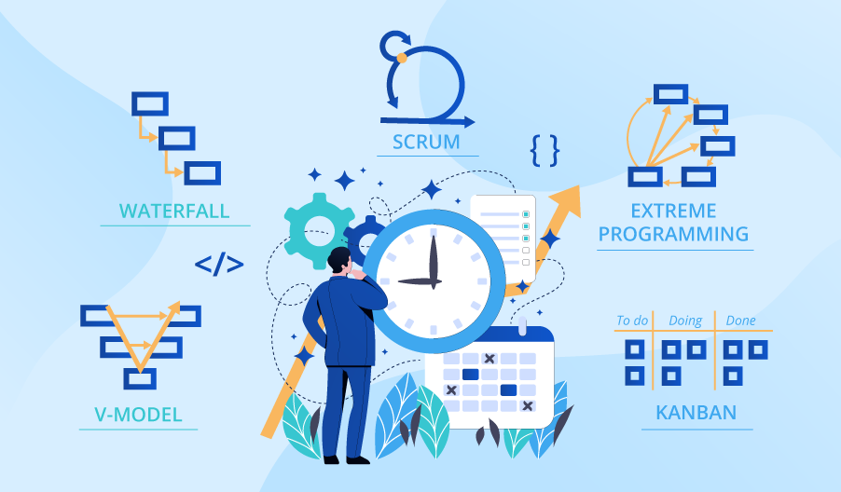

**SE423**

**Software Project Management**

**Activity**

**Activity 7. Software Quality Activity**

1. In groups, come up with a definition for software quality. Discuss why quality is important in software development. Share definitions as a class and synthesize a comprehensive definition.
2. As a class, explain the concept of software quality assurance and its role in ensuring high-quality software. Discuss how it differs from software testing.
3. In groups, identify 5 common SQA activities. Have each group rank them from 1 (most effective) to 5 (least effective) in ensuring quality. Share rankings with the class and come to a consensus on the top 3 most effective activities.
4. Individually, compare pros and cons of 3 software review techniques: informal review, walkthrough, inspection. Consider perspectives of both the reviewer and the author. Come prepared to share with the class. Discuss as a class.
5. Individually, analyze options for how to proceed with inspections given the time constraint, including:

* Reducing the rigor of inspections
* Having team leads perform inspections and report summaries to authors
* Only inspecting high-risk modules
* Temporarily reassigning team members to focus on inspections
* Extending the project timeline

Recommend one option and justify your choice based on a balance of timeline, quality, and cost impact. Be prepared to share recommendation and rationale with class. Discuss options as a class.

Be sure to include all group member's names in your submission.